**A Project report on**

**DETECTION OF ALZHEIMER’S DISEASE THROUGH**

**EEG SIGNALS OF PATIENT**

***in partial fulfilment for the award of the degree of***

**BACHELOR OF TECHNOLOGY**

**In**

**COMPUTER SCIENCE AND ENGINEERING**

***Submitted by***

**SAVARAM POKHRAN ROYAL (20B91A05R6)**

**PENMATCHA YASASWINI A LATHA (20B91A05N6)**

**PAMOTI GNANESHA (20B91A05L9)**

**PENMATCHA SAI NARASIMHA RISHIT VARMA (20B91A05N5)**

***Under the Guidance of***

M.JANAKI DEVI

Assistant Professor



**DEPARTMENT OF COMPUTER SCIENCE AND ENGINEERING**

**SRKR ENGINEERING COLLEGE (A)**

Chinna Amiram, Bhimavaram, West Godavari Dist., A.P.

[2023 – 2024]

**DEPARTMENT OF COMPUTER SCIENCE AND ENGINEERING**

**SRKR ENGINEERING COLLEGE (A)**

ChinnaAmiram, Bhimavaram, West Godavari Dist., A.P.

[2023 – 2024]



**BONAFIDE CERTIFICATE**

This is to certify that the project work entitled **“DETECTION OF ALZHEIMER’S DISEASE THROUGH EEG SIGNALS OF PATIENT”** is the bonafide work of **SAVARAM POKHRAN ROYAL**, **PENMATCHA YASASWINI A LATHA, PAMOTI GNANESH, PENMATCHA SAI NARASIMHA RISHIT VARMA** **bearing 20B91A05R6, 20B91A05N6, 20B91A05L9, 20B91A05N5** who carried out the project work under my supervision in partial fulfilment of the requirements for the award of the degree of Bachelor of Technology in Computer Science and Engineering.

**SUPERVISOR HEAD OF THE DEPARTMENT**

(M.Janaki Devi) ( Dr V Chandra Sekhar )

Assistant Professor Professor

**SELF DECLARATION**

We hereby declare that the project work entitled **“DETECTION OF ALZHEIMER’S DISEASE THROUGH EEG SIGNALS OF PATIENT”** is a genuine work carried out by us in B.Tech., (Computer Science and Engineering) at SRKR Engineering College(A), Bhimavaram and has not been submitted either in part or full for the award of any other degree or diploma in any other institute or University.

**1.SAVARAM POKHRAN ROYAL 20B91A05R6**

**2. PENMATCHA YASASWINI A LATHA 20B91A05N6**

**3.PAMOTI GNANESH 20B91A05L9**

**4.PENMATCHA SAI NARASIMHA RISHIT VARMA 20B91A05N5**

**TABLE OF CONTENTS**

|  |  |  |
| --- | --- | --- |
| **S. NO** | **CONTENTS** | **PAGE NO** |
|  | ABSTRACT | i |
|  | LIST OF FIGURES | ii |
|  | LIST OF TABLES | iii |
| 1. | INTRODUCTION |  |
| 2. | LITERATURE SURVEY |  |
| 3. | PROLEM STATEMENT |  |
| 4. | SYSTEM ANALYSIS |  |
| 5. | METHODOLOGY |  |
| 6. | IMPLEMENTATION |  |
| 7. | RESULT ANALYSIS |  |
| 8. | CONCLUTION |  |
| 9. | REFERENCES |  |

**ABSTRACT**

Alzheimer`s disease (AD) is a brain neurological condition that results in the destruction of neurons. Computational analysis of electroencephalographic (EEG) signals has shown promise in diagnosing brain diseases, such as Alzheimer's disease (AD). Alzheimer's disease (AD) is a degenerative neurological condition that impairs cognition by degenerating neuron cells. Even though AD is no known cure, early detection is essential to enhancing the lives of those who are impacted.

Clinical decision support for a range of conditions, such as diabetic retinopathy1, tumors, and Alzheimer's disease, has demonstrated great promise with deep learning (DL). Given a collection of labeled instances, DL's primary advantage over other shallow learning models is its capacity to extract the best predictive characteristics straight from the raw data. The purpose of this work is to use various techniques, such as CNN algorithms, to identify AD in EEG data and to look into the characteristics of the signals that identify the various patient groups.

i

# LIST OF FIGURES

|  |  |  |
| --- | --- | --- |
| **S.NO** | **CONTENT** | **PAGE. NO** |
| 1. | Brain damaged neurons Identification | 1 |
| 2. | Stages of Alzheimer’s disease | 2 |
| 3. | System Architecture |  |
| 4. | Convolutional Neural Network model |  |
| 5. | Random Forest Architecture |  |

ii

**LIST OF TABLES**

|  |  |  |
| --- | --- | --- |
| **S.NO** | **CONTENTS** | **PAGE NO** |
| 1. | Accuracy of models |  |

iii

1. **INTRODUCTION**

**Alzheimer's Disease:**

Alzheimer's disease (AD) is one of the most common and debilitating neurological diseases, impacting millions of people globally. It is a multifaceted illness marked by a slow deterioration in cognitive function that causes significant problems with memory, thought, and behaviour. Since the disease was first discovered in 1906 by German neuropathologist and psychiatrist Alois Alzheimer, it has been the subject of extensive scientific investigation, but a permanent cure is still unattainable.

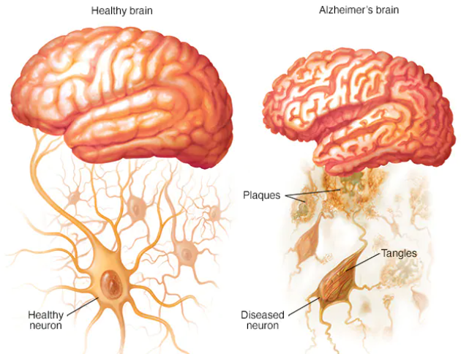

Fig 1: Brain damaged neurons Identification

The disease's pathogenic features include aberrant protein aggregates building up in the brain. The neurodegenerative process is accelerated by these aggregates, which also impair neural function. Extracellular plaques are created when beta-amyloid protein fragments accumulate. Enzymes known as beta-secretase and gamma-secretase cleave the amyloid precursor protein (APP) to create beta-amyloid. Aggregation of insoluble plaques is caused by an imbalance in the generation and clearance of beta-amyloid in Alzheimer's disease. These plaques lead to neuronal damage and death by interfering with neuronal transmission and inducing inflammatory responses. Tau proteins are crucial for maintaining neuronal microtubule stability and promoting intracellular trafficking. When tau proteins in Alzheimer's disease get over phosphorylated, they separate from microtubules and congregate inside neurons to form neurofibrillary tangles. These tangles interfere with cellular transport processes, cause neuronal malfunction, and ultimately lead to neuronal death by upsetting the structure and function of neurons.

**Clinical Presentation**:

Alzheimer's disease usually develops in phases, with specific cognitive and functional deficits associated several stages:

People may have mild pathological and metabolic alterations in the brain during the preclinical stage without exhibiting any symptoms. A stage in between normal aging and dementia is known as mild cognitive impairment (MCI). Mild cognitive deficits are visible but do not substantially interfere with day-to-day functioning in individuals with MCI. Individuals experience modest cognitive symptoms as the disease advances, including forgetfulness, language difficulties, and difficulties with planning and problem-solving. The moderate stage is characterized by a more noticeable cognitive deterioration and a potential need for assistance with everyday activities. Additionally, there may be behavioural and psychological signs like hostility, restlessness, and agitation. In the most advanced stages, people lose significant cognitive and functional abilities, including the capacity to identify and interact with loved ones and carry out simple self-care duties.

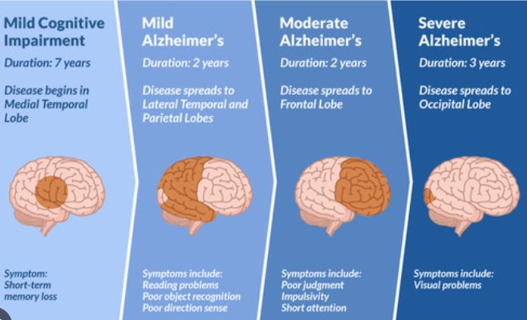

Fig 2: Stages of Alzheimer’s disease

**Diagnosis and Treatment:**

A thorough evaluation of cognitive function, medical history, physical examination, and neuropsychological testing are all necessary for the diagnosis of Alzheimer's disease. Magnetic resonance imaging (MRI), electroencephalography (EEG), and positron emission tomography (PET) scans are examples of brain imaging techniques that can be used to rule out other illnesses and identify the distinctive brain abnormalities linked to Alzheimer's disease.

Several therapeutic methods are available to manage symptoms and reduce the advancement of Alzheimer's disease, despite the fact that there is presently no cure for the condition. Among these are behavioural therapies, physical activity, social interaction, and cognitive stimulation, all of which can enhance quality of life and assist both Alzheimer's patients and their careers. Drugs like galantamine, rivastigmine, and donepezil serve to raise acetylcholine levels in the brain.

**Challenges and Future Directions:**

Even while our understanding of Alzheimer's disease has advanced, there are still many obstacles in the way of creating interventions and treatments that work. These include the disease's intricacy, the challenges associated with an early diagnosis, and the requirement for more accurate biomarkers and treatment targets. Furthermore, Alzheimer's affects not just the afflicted person but also their family, caregivers, and society at large, emphasizing the critical need for all-encompassing care and support services.

As we move forward, it will be crucial to sustain research efforts focused on figuring out the fundamental causes of Alzheimer's disease, finding new therapeutic targets, and creating creative treatment plans in order to battle this terrible illness and lessen its severe effects on people and communities around the globe. We may work toward a future where efficient prevention and treatment techniques are available to lessen the burden of Alzheimer's disease and improve the lives of those afflicted by it by encouraging collaboration between researchers, doctors, caregivers, and legislators.

1. **LITERATURE SURVEY**

|  |  |  |  |  |
| --- | --- | --- | --- | --- |
| **S NO.** | **TITLE** | **AUTHOR** | **METHODOLOGY USED** | **KEY FINDINGS** |
| 1. | “Detection of Alzheimer's Disease from Electroencephalography (EEG) Signals Using Multitaper and Ensemble Learning Methods"  (2023) | Hanife GÖKER | The paper utilizes multitaper and ensemble learning methods for detecting Alzheimer's disease from EEG signals. | The study explores the utilization of multitaper and ensemble learning techniques to detect Alzheimer's disease from EEG signals. By combining these methods, the research aims to enhance the accuracy of Alzheimer's disease diagnosis, contributing to advancements in medical signal processing and diagnosis. |
| 2. | “Smart-Data-Driven System designed for the detection of Alzheimer's disease using (EEG) signals”  (2022) | Teresa Araújo, João Paulo Teixeira, and Pedro Miguel Rodrigues | The methodology likely involves EEG data collection, preprocessing for quality enhancement, feature extraction to identify Alzheimer's patterns, development of a predictive model using machine learning, and validation in real-world scenarios, integrating data-driven approaches, advanced signal processing, and machine learning techniques. | The system utilizes advanced signal processing techniques and machine learning algorithms to analyze EEG signals and identify patterns associated with Alzheimer's disease. |
| 3. | “Early detection of Alzheimer’s disease from EEG signals using Hjorth parameters”  (2021) | Mehrnoosh Sadat Safi, Seyed Mohammad Mehdi Safi | The research likely involves acquiring EEG signals from Alzheimer's patients and healthy individuals, preprocessing the data, and extracting features based on Hjorth parameters. Machine learning methods are then applied to develop a model for early Alzheimer's detection, with potential validation to evaluate model performance. | It explores the potential of utilizing EEG signals and Hjorth parameters for the early detection of Alzheimer's disease.The study investigates how specific EEG signal features, known as Hjorth parameters, can indicate the presence of Alzheimer's disease at its early stages. |
| 4. | “Alzheimer's disease detection through EEG using deep learning methods“  (2020) | A. Ghasemi, M. A. Haque, H. Ghassemian, A. M. Nasrabadi | The paper employs deep learning techniques for detecting Alzheimer's disease from EEG signals.Data collection, Model development and evaluation. | By training models to analyze EEG data and evaluating their performance, the research highlights the effectiveness of deep learning approaches in improving diagnostic capabilities for Alzheimer's disease. |
| 5. | “Early diagnosis ofAlzheimer’s disease: the role of biomarkers including advanced EEG signal analysis”  (2020) | P.M. Rossini, R. Di Iorio, F. Vecchio, M. Anfossi, C. Babiloni, M. Bozzali, A.C. Bruni, S.F. Cappa, J. Escudero, F.J. Fraga, P. Giannakopoulos, Miraglia, F. Panza, F. Tecchio, A. Pascual-Leone, and B. Dubois | The research likely involves utilizing advanced EEG signal analysis techniques to identify biomarkers for early Alzheimer's disease diagnosis. EEG signals are collected and analyzed using sophisticated methods to detect subtle neurological changes associated with the disease. The study may involve collaboration among experts from various fields to comprehensively assess the role of EEG biomarkers in Alzheimer's diagnosis. | This study emphasize the significance of using biomarkers, particularly advanced EEG signal analysis, in improving early detection and management of AD. |
| 6. | “Alzheimer's disease detection with deep neural  networks using EEG"  (2019) | E. Vayrynen, M. Karrasch, M. Marttinen, J. Lötjönen,  C. H. Wolters | The paper employs deep neural networks (DNNs) for detecting Alzheimer's disease from EEG signals.Data collection, Model development and evaluation. | By training DNNs to analyze EEG data and evaluating their  performance, the study underscores the effectiveness of deep learning methods in enhancing diagnostic capabilities for Alzheimer's disease. |
| 7. | “Deep learning-based detection of Alzheimer's disease using EEG signals”  (2019) | K. Samiee, H. Ghassemian, A. M. Nasrabadi | The paper utilizes deep learning techniques for Alzheimer's disease detection from EEG signals.  Data collection,Model development and evaluation. | The study investigates the efficacy of deep learning methods for detecting Alzheimer's disease using EEG signals. By training models to analyze EEG data and assessing their performance, the research highlights the promise of deep learning |
| 8. | “A novel methodology for automated differential diagnosis of mild cognitive impairment and Alzheimer's disease using EEG signals"  (2019) | Juan P. Amezquita-Sanchez, Nadia Mammone, Francesco C. Morabito, Silvia Marino, Hojjat Adeli | The research likely involves collecting EEG signals from individuals with mild cognitive impairment (MCI) and Alzheimer's disease, followed by preprocessing to enhance data quality. Feature extraction techniques are then applied to differentiate between MCI and Alzheimer's disease patterns, potentially utilizing machine learning algorithms for automated diagnosis. | The study proposes a novel methodology that utilizes EEG signals for automated diagnosis. By analyzing EEG patterns, the research aims to provide a reliable and efficient tool for clinicians to differentiate between MCI and AD, facilitating early intervention and personalized treatment strategies |
| 9. | “Deep Learning in Alzheimer's Disease Detection from EEG Signals“  (2018) | C. Gómez, F. Valencia, J. J. Jiménez | The paper employs deep learning techniques for Alzheimer's disease detection using EEG signals.  Data Collection ,Model Training and Evaluation | By training models on EEG data and evaluating their performance, the study demonstrates the potential of deep learning in improving diagnostic accuracy for Alzheimer's disease |
| 10. | "Detection of Alzheimer's Disease Using Deep Convolutional Neural Networks and Transfer Learning with Spectrograms of EEG Signals“ (2018) | I. Titov, I. Dedinská, L. Kačicová | The study employs deep convolutional neural networks (CNNs) and transfer learning techniques.  Data Collection, Preprocessing ,Model Training and Evaluation | By transforming EEG signals into spectrograms and leveraging pre-trained models, the study aims to improve Alzheimer's diagnosis accuracy, presenting a promising approach for utilizing deep learning in medical diagnosis. |

1. **PROBLEM STATEMENT**

Alzheimer's disease (AD) is a neurological illness that worsens over time and impacts behavior, memory, and cognitive function. For management and treatment to be effective, early diagnosis and intervention are essential. Since conventional diagnostic techniques frequently have low sensitivity and specificity, it is critical to design trustworthy, non-invasive instruments. to research and create a new method for employing EEG-based neuroimaging to diagnose Alzheimer's disease early. The efficacy of current diagnostic techniques in identifying reliable biomarkers for Alzheimer's disease early detection is limited. Using EEG data to understand the brain processes linked to Alzheimer's disease presents considerable hurdles. creating readily administered, non-invasive techniques, particularly for communities that are at risk. Because EEG data is so complicated, meaningful analysis requires the use of modern signal processing and machine learning techniques. Using machine learning methods, neural network designs, and sophisticated signal processing techniques, the suggested solution analyses EEG data to find patterns that are specific to Alzheimer's disease. From the pre-processed EEG recordings, extract pertinent information using sophisticated signal processing techniques. Spectral power, connection metrics, and other time-frequency domain representations are examples of features.

1. **SYSTEM ANALYSIS**
   1. **EXISTING SYSTEM:**

The current methodology determines the illness details using regression models like logistic and linear and algorithms like Random Forest Classifier; however, these algorithms are slow and produce poor accuracy. They are also not time-efficient. Examining intricate and changing patterns in patient Alzheimer's disease data can be difficult because the data is usually dispersed, large-scale, diverse, and entirely autonomous. Some learning models are decades old and perform poorly in terms of speed, accuracy, efficiency, and processing time, even though the current system works well with the Random Forest Classifier theorem, which describes the possibilities of the massive information revolution and implements a large processing model.

* 1. **PROPOSED SYSTEM:**

The suggested system is a Convolutional Neural Network (CNN), skilled in automatically extracting features from unprocessed time-series data, and specifically designed for signal classification tasks. The architecture consists of MaxPooling1D and AveragePooling1D for reducing spatial dimensions, Batch Normalization for normalization, LeakyReLU activations for enhanced gradient flow, and Conv1D layers with 3-size kernels and 5 filters. GlobalAveragePooling1D layer unifies features into a single vector, preventing overfitting, while dropout layers produce a dense layer with a sigmoid activation for classification.

In contrast, Random Forest classifiers might not be as effective at classifying signals as CNNs, despite their robustness. CNNs learn hierarchical features on their own, while Random Forest relies on hand-crafted, frequently less effective, features. Because of their complex feature extraction, CNNs scale well to huge datasets and generalize better to new data. However, when dealing with large amounts of data, Random Forests may struggle with memory and computational limitations, increasing the likelihood of overfitting and requiring careful hyperparameter tweaking. Therefore, compared to the Random Forest classifier, the suggested CNN model provides a more sophisticated, scalable, and all-encompassing solution for signal categorization.

# SYSTEM REQUIREMENTS:

**4.3.1 HARDWARE REQUIREMENTS:**

* Operating system : Windows
* Processor : Intel core-i7
* Ram : 16 Giga Bytes
* Hard Disk : 512 GB

**4.3.2 SOFTWARE REQUIREMENTS:**

* Software used : Google Colaboratory/Jupiter Notebook
* Python libraries : Numpy, Pandas, Matplot, sklearn, seaborn.....
  + 1. **FUNCTIONAL REQUIREMENTS:**
       - Gathering the required Data
       - Pre-Processing of data
       - Smote the dataset
       - Train and test the data
       - Modelling
       - Predicting

1. **METHODOLOGY:**

**5.1 SYSTEM ARCHITECTURE:**

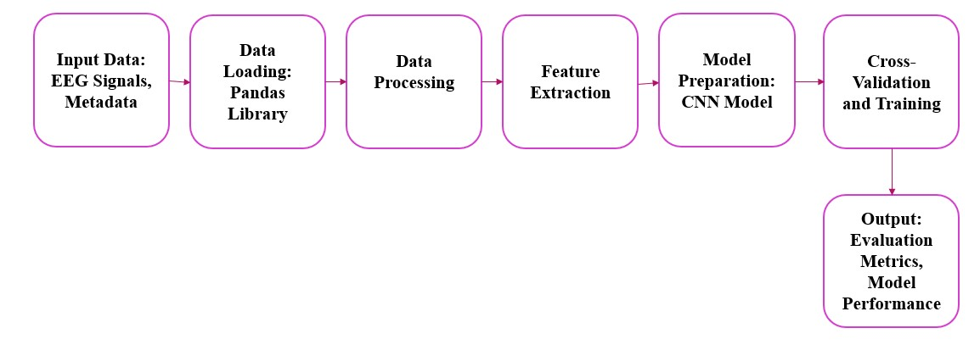

Fig 3: System Architecture

**5.2 DATASET:**

As participants remained in a relaxed state with eyes closed, fifteen minutes of EEG data was collected at a sampling rate of 250 Hz. Data was obtained via the typical International 10–20 System. The electrodes used were Fp1, Fp2, F7, F3, Fz, F4, F8, T3, C3, Cz, C4, T4, T5, P3, Pz, P4, T6, O1, O2. The reference electrode was placed between electrodes Fz and Cz. Access to such high-quality data from reputable sources like RepOD facilitates rigorous investigation and validation of diagnostic and prognostic markers, potentially leading to improved early detection and management strategies for Alzheimer's disease and related conditions**.** Quality of life is then compromised, with most SZ patients being unable to function in workplaces, 20–40% attempting suicide at least once, and between 5–10% successfully committing suicide.

# ALGORITHMS USED:

# 5.3.1 Convolutional Neural Network

# The cnnmodel() function defines a Convolutional Neural Network (CNN) using the Keras framework with a TensorFlow backend. The model starts with a Conv1D layer that processes input sequences of length 5000 with 19 features using 10 filters of size 5 and a stride of 1. This is followed by a Batch Normalization layer that normalizes the activations to have a mean close to 0 and a standard deviation close to 1. An activation layer using LeakyReLU is then applied, allowing a small gradient when the unit is not active, which helps prevent dead neurons. Subsequently, a MaxPool1D layer with a pool size of 2 and strides of 2 performs max pooling, reducing the spatial dimensions by half.

# Fig 4: Convolutional Neural Network

# To mitigate overfitting, a Dropout layer is introduced with a rate of 0.5, randomly setting 50% of the input units to 0 during training. Another Conv1D layer identical to the previous one follows, with a subsequent Batch Normalization and LeakyReLU activation. An AveragePooling1D layer with a pool size of 2 and strides of 2 then performs average pooling. The model further includes another Conv1D layer, followed by Batch Normalization and LeakyReLU activation. Instead of a traditional dense layer, a GlobalAveragePooling1D layer converts the spatial feature maps into a single 1D vector. Finally, a Dense layer with a single output unit and a sigmoid activation function is added for binary classification. For training, the model utilizes the Adam optimizer with a learning rate of 0.001 and employs the binary crossentropy loss function. The model's performance is evaluated using accuracy metrics during both training and validation phases.

# 5.3.2 RANDOM FOREST

# Random forest is an effective ML algorithm commonly utilized for solving classification and regression problems. It employs ensemble learning methodology by combining multiple decision trees and aggregating their outputs for making predictions. As a supervised learning algorithm, it requires labelled training data to learn from, thereby yielding highly accurate results.

# 

# Fig 5: Random Forest Architecture

# The random forest algorithm works by selecting a bootstrap data sample from a dataset X for each tree in the forest. At each node of the tree, a decision tree is learned using a modified learning algorithm of the decision tree. Rather than examining all possible feature-splits, a random subset of features b, which is a subset of the set of all features B, is selected. The node then splits on the best feature in b, rather than considering all features in B. This approach speeds up the learning of the tree significantly, as determining which feature to split on is typically the most computationally expensive aspect of decision tree learning. For each sample, individual decision trees are constructed and the best learner is checked if it exists. The final output is then determined using Averaging or Majority Voting for regression and classification respectively.

# 5.3.3 XG BOOST

# Gradient boosting and XG Boost are both techniques used for building powerful machine learning models by adding finite multiple weak models (usually decision trees) to build a stronger and more accurate model. The XG Boost works by iteratively training the decision tree on residual errors of the previous tree, which reduces the overall prediction error. XG Boost is a more optimized and flexible implementation of gradient boosting. The figure-6 shows the working architecture of XG Boost

1. **IMPLEMENTATION:**

Implementation for "Detection of Alzheimer's disease through EEG signals of patients" using deep learning:

1. Data Extraction:

Collecting EEG signals from patients diagnosed with Alzheimer's disease and from healthy individuals. Ensure the data includes a sufficient number of samples representing Alzheimer's Disease. Utilizing standardized EEG recording protocols to maintain consistency across datasets. Storing the collected EEG data in a structured format for further analysis.

2. Data Preprocessing:

Cleaning the raw EEG signals by removing noise, artifacts, and baseline drift. Segmenting the EEG signals into smaller epochs to focus on specific time intervals for analysis. Applying techniques such as filtering to enhance relevant frequency components of the EEG signals. Normalizing the EEG data to ensure consistency in amplitude and scale across samples. Splitting the pre-processed data into training, validation, and testing sets for model development and evaluation.

3. Data Insights Extraction:

Using deep learning architectures like convolutional neural networks (CNNs) to analyse EEG signals. Training the deep learning models on the pre-processed EEG data to learn distinctive patterns associated with Alzheimer's disease. Evaluating the trained model using performance metrics such as accuracy, sensitivity, specificity, and area under the curve (AUC). Extracting insights from the trained models to understand the key features and patterns indicative of Alzheimer's disease in EEG signals.

By following this methodology, the project aims to develop a deep learning-based system capable of accurately detecting Alzheimer's disease from EEG signals, providing valuable insights for diagnosis and monitoring of the condition.

1. **RESULT ANALYSIS:**

After preparing the brainwave data by cleaning and organizing it, we designed our program to look for patterns that could indicate Alzheimer's disease. Our program has layers that 'learn' these patterns and make sense of the brainwave signals. We tested our program thoroughly using different sets of data and found that it could correctly identify Alzheimer's disease with an accuracy of 84%. This means our program is pretty good at spotting signs of Alzheimer's disease in EEG tests, which could be a helpful step towards early detection and treatment.

**Results Obtained**

**Confusion Matrix**

In the following confusion matrices below, depict the predicted labels in the columns and the true labels in the rows. The elements along the diagonal of the matrix correspond to the number of accurate predictions made by the classifier, whereas the elements off the diagonal indicate the number of incorrect predictions. Each row of the matrix corresponds to a specific true label and shows how many times that label was incorrectly predicted as each of the possible predicted labels.

|  |  |
| --- | --- |
| **MODEL** | **ACCURACY** |
| Convolutional Neural Network | 0.8444716556712932 |
| Random Forest Classifier | 0.7175119125460665 |
| XG BOOST | 0.7034356546401977 |

Table 1: Accuracy of models

# Confusion Matrix

The structure of a confusion matrix looks like a table that used to evaluate the classification algorithm performance. It is a valuable tool in predictive analysis for machine learning models. By using a confusion matrix, one can quickly visualize and summarize the performance of a classification algorithm technique. Confusion matrix is especially useful for evaluating binary classification tasks, as it provides a summary table of incorrect and correct output generated by the classifier's prediction. Recall, Precision, F1-score and Accuracy are some of the key metrics that can be derived from a confusion matrix. Figure-14 demonstrates a general representation of a confusion matrix.

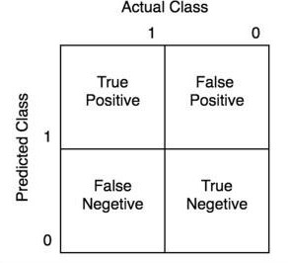

Fig : Confusion Matrix

* **True Positive (TP):** Here actual class is true & the model predicts a positive.
* **False Positive (FP)**: Here actual class is false but the model predicts a positive.
* **False Negative (FN):** Here actual class is false & the model predicts a negative.
* **True Negative (TN):** Here actual class is true but the model predicts a negative.

# Accuracy:

This accuracy metric on the entire test dataset will measures how many correct predictions a model can made and it is good basic measure of model performance. However, in datasets where there is an imbalance between the number of instances of each class, accuracy may not be a reliable metric.

(𝐓𝐏 + 𝐓𝐍)

𝐀𝐜𝐜𝐮𝐫𝐚𝐜𝐲 = (𝐓𝐏 + 𝐓𝐍 + 𝐅𝐏 + 𝐅𝐍)

1. **CONCLUSION**

To Predict Alzheimer's disease in the body, we proposed a system which consists of machine learning algorithms like XG Boost, CNN, Random Forest. The proposed models can naturally operate on an input of instances. We conducted experiments on the collected dataset. Among them, comparison has been done and identified that the accuracy obtained by CNN is 84%, Random Forest is 72% and XG Boost is 71%. Among all the algorithms, CNN obtained the best accuracy results. So, we concluded that this system is successful in predicting patient data with best accuracy. And prepared a user interface where the user can provide the EEG signals report as an input to the model where we have stored the model in a pickle format. And from this model we will be giving the patients some precautions so that they can be treated. Moving forward, continued refinement and validation of our models hold the potential to translate into tangible benefits for patients, caregivers, and healthcare professionals alike.

1. **REFERENCES**

[1] Early Stage Alzheimer's Detection Using EEG, (Afsa S, Disla Abdulla, Ambadi .M. Nair, Fathima) B. Tech Student, Dept. of ECE, Adi Shankara Institute of Engineering & Technology, Kalady ,Cochin (Ms. Remya Ramesh) Assistant Professor, Department of ECE, Kalady, Cochin

[2] A novel methodology for automated differential diagnosis of mild cognitive impairment and Alzheimer's disease using EEG signals", Juan P. Amezquita-Sanchez, Nadia Mammone, Francesco C. Morabito, Silvia Marino, Hojjat Adeli

[3] Early diagnosis ofAlzheimer’s disease: the role of biomarkers including advanced EEG signal analysis, P.M. Rossini, R. Di Iorio, F. Vecchio, M. Anfossi, C. Babiloni, M. Bozzali, A.C. Bruni, S.F. Cappa, J. Escudero, F.J. Fraga, P. Giannakopoulos, B. Guntekin, G. Logroscino, C. Marra, F. Miraglia, F. Panza, F. Tecchio, A. Pascual-Leone, and B. Dubois

[4] Early detection of Alzheimer’s disease from EEG signals using Hjorth parameters, Mehrnoosh Sadat Safi, Seyed Mohammad Mehdi Safi

[5] Smart-Data-Driven System designed for the detection of Alzheimer's disease using (EEG) signals, Teresa Araújo, João Paulo Teixeira, and Pedro Miguel Rodrigues

[6] Detection of Alzheimer's Disease from Electroencephalography (EEG) Signals Using Multitaper and Ensemble Learning Methods, Hanife GÖKER